To access the project, please enter the "New Unity Project (4)" folder, then "Assets", then "Scenes", and after that, click on the "EduardIablonschi-s188800-EmergingTechnologies" scene for Unity.

My task for this module, [ICGP Emerging Technologies - 18/19](https://brightspace.uos.ac.uk/d2l/home/15011), is to create a project in which the user is able to use the Leap Motion device to control virtual hands, pick up an object inside a game, and place it in a specific place. The player has 3 objects which need to be placed accordingly, so that the game will be won.

I have begun working on my project by trying to reuse work I have done up until this semester, which I eventually did manage to reuse, after reinstalling the following software programs and/or packages, so that they would be up to date: Leap Motion Orion, the Leap Motion Core Assets, and the Leap Motion Interaction Engine. Doing this was also suggested in the video series tutorial I was meant to follow.

I have used the Leap_Hands_Demo_Desktop scene, which was present in the Leap Core folder in Unity, as a means to move the Virtual Hands with the Leap Motion without having to import the Leap Rig, which would have been an alternative. I have added a plane on which all objects would be placed, and just one 3D cube, at first. This is the first time when I had encountered difficulties, because one of the videos from the tutorial series didn’t focus on explaining the essentials, and I did lose quite some time until I figured out that the next essential step was to add the interaction manager into the scene, and after that, I added a behaviour script and a rigidbody to the cube. By doing these steps, I was able to pick up that cube while slightly clenching my fist and move it around.

However, I soon stumbled upon other problems: I realized that the hand movements weren’t exactly smooth, and that while waving my hand up and down, without holding an object, the virtual hand would come into contact with the object in its vicinity and would send it flying across the map. Unfortunately, I still haven’t been able to find solutions for these problems, so I had to keep them in mind while continuing to develop the project.

As a workaround, I have tried to increase their mass and I changed the gravity scale, but that did not seem to have any visible impact, therefore I have placed 4 walls which prevent the objects from going through them and from being thrown so far away that the player wouldn’t be able to pick them up anymore. Also, I have placed a light source in the scene, so that anything necessary would be visible.

I tried adding objects with different shapes from one another – a cube, a sphere and a cylinder – however, I found that the cube was easier to pick up compared to the other objects, even though I tried replacing their capsule colliders with box colliders, in hope that this would solve the problem. As a result, I have replaced the cylinder and sphere with other cubes, and I have coloured them differently. The spaces in which the cubes were supposed to be placed would also be coloured almost similarly to their corresponding cube which would need to be placed there, instead of also having different shapes.

The player knows that the cubes are placed in the correct spots by receiving messages from the Unity console. I have made use of colliders and triggers in order to make this work. If the cubes are placed correctly, the game will look like this:

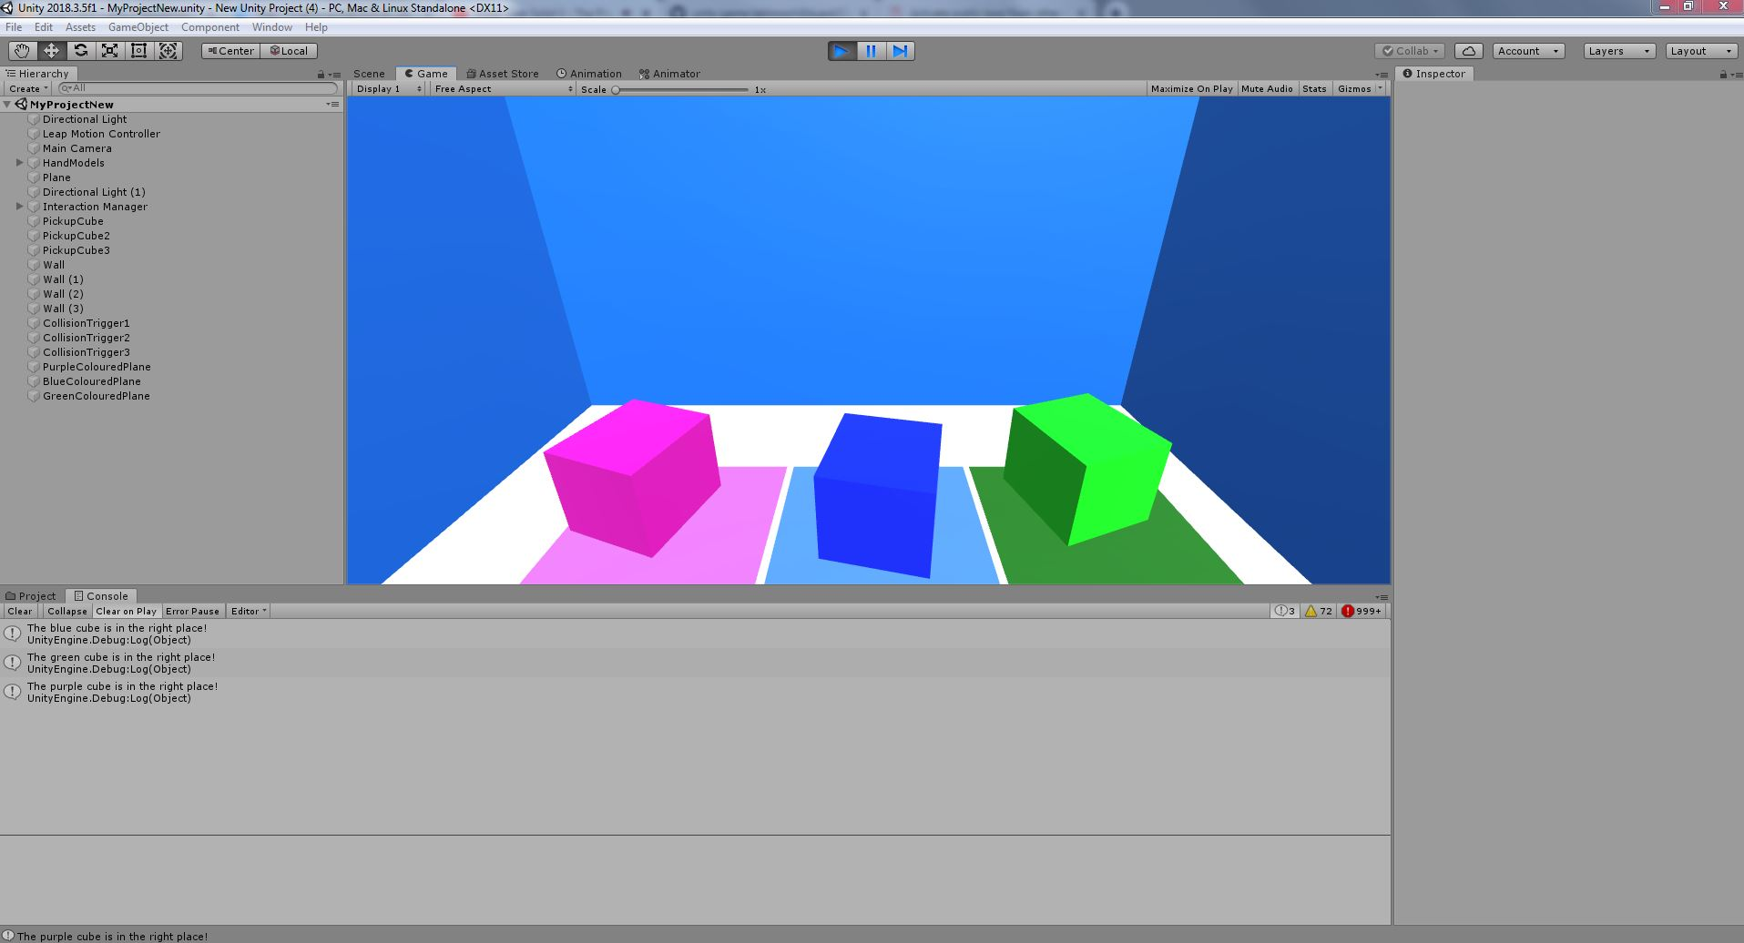

One final problem I came across was not being able to implement an end screen, which would show up on the screen when all 3 cubes are placed on their specific colours. That is because I have not managed to create references to the public Boolean values I have set up in the scripts. I did try a couple of methods, but none of them seemed to work in my case.